**Project Design Phase-II**

**Data Flow Diagram & User Stories**

|  |  |
| --- | --- |
| Date | 27 June 2025 |
| Team ID | LTVIP2025TMID59438 |
| Project Name | ShopSmart: Your Digital Grocery Store Experience |
| Maximum Marks | 4 Marks |

**Data Flow Diagrams:**

A Data Flow Diagram (DFD) is a traditional visual representation of the information flows within a system. A neat and clear DFD can depict the right amount of the system requirement graphically. It shows how data enters and leaves the system, what changes the information, and where data is stored.

**Example:** [**(Simplified)**](https://developer.ibm.com/patterns/visualize-unstructured-text/)

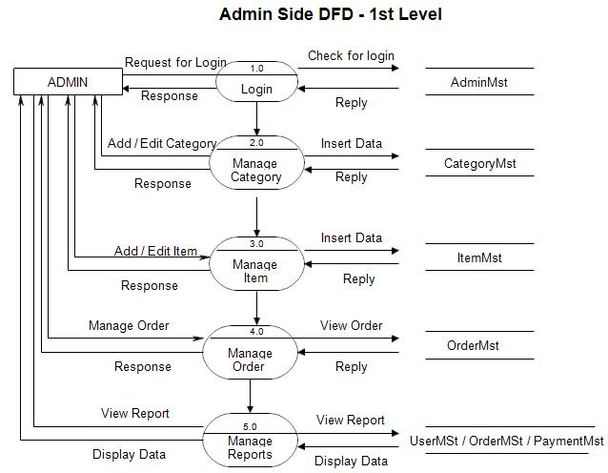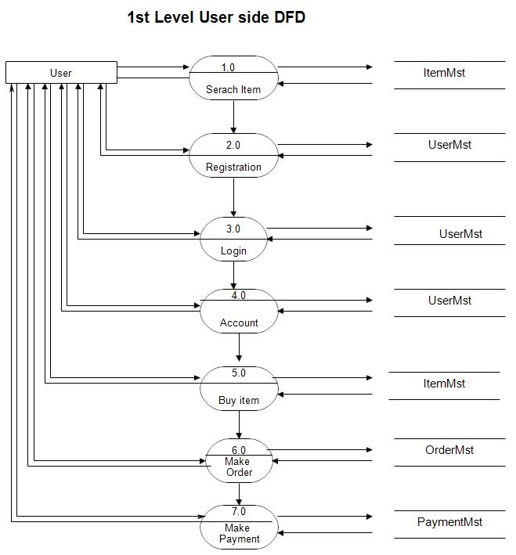

**User Stories**

|  |  |  |  |  |  |  |
| --- | --- | --- | --- | --- | --- | --- |
| **User Type** | **Functional Requirement (Epic)** | **User Story Number** | **User Story / Task** | **Acceptance Criteria** | **Priority** | **Release** |
| Customer | Registration | USN-1 | As a user, I can register with my email and password. | I can access my account/dashboard after registration. | High | Sprint-1 |
|  | Login | USN-2 | As a user, I can log in securely with email and password. | I can access my dashboard after successful login. | High | Sprint-1 |
|  | Profile Management | USN-3 | As a user, I can view and update my profile information. | I can see my updated name and email on the profile page. | High | Sprint-1 |
|  | Product Browsing & Search | USN-4 | As a user, I can browse and search available products by name or category. | I can see all relevant items that match my filters or search query. | High | Sprint-1 |
|  | Shopping Cart & Checkout | USN-5 | As a user, I can add items to my cart and proceed to checkout. | My order is successfully placed and appears in my order history. | High | Sprint-1 |
|  | Order Tracking | USN-6 | As a user, I can track my order status (e.g., confirmed, shipped, delivered). | The order status updates on my orders page. | High | Sprint-1 |
|  | Feedback | USN-7 | As a user, I can submit feedback or reviews for purchased products. | My rating and comment are saved and visible to admins or other shoppers. | Medium | Sprint-2 |
| Seller | Registration & Approval | USN-8 | As a seller, I can register and await admin approval to start listing products. | I am notified once my account is approved by the admin. | High | Sprint-1 |
|  | Store Profile Management | USN-9 | As a seller, I can update my store’s name | Changes are reflected on the seller’s store profile. | High | Sprint-1 |
|  | Product Catalog Management | USN-10 | As a seller, I can add, edit, and delete items in my product catalog. | New or modified items are visible to customers. | High | Sprint-1 |
|  | Order Fulfillment | USN-11 | As a seller, I can view customer orders and update their status. | I can mark orders as packed, shipped, or delivered. | High | Sprint-1 |
|  | Support | USN-12 | As a seller, I can contact admin with feedback. | My message is visible in the admin panel. | Medium | Sprint-2 |
| Admin | User Management | USN-13 | As an admin, I can view all customer and seller accounts. | I can filter and manage all registered users. | High | Sprint-1 |
|  | Seller Approval | USN-14 | As an admin, I can approve or reject seller registrations. | Approval status changes and is reflected in the seller’s dashboard. | High | Sprint-1 |
|  | Category Management | USN-15 | As an admin, I can manage product categories in the system. | Categories appear in the dropdowns for sellers during item creation. | High | Sprint-1 |
|  | Dashboard & Reports | USN-16 | As an admin, I can view platform metrics (orders, sales, users). | Dashboard is updated in real-time. | High | Sprint-1 |